**CYCLOMATIC COMPLEXITY-2**

**PROGRAM:**

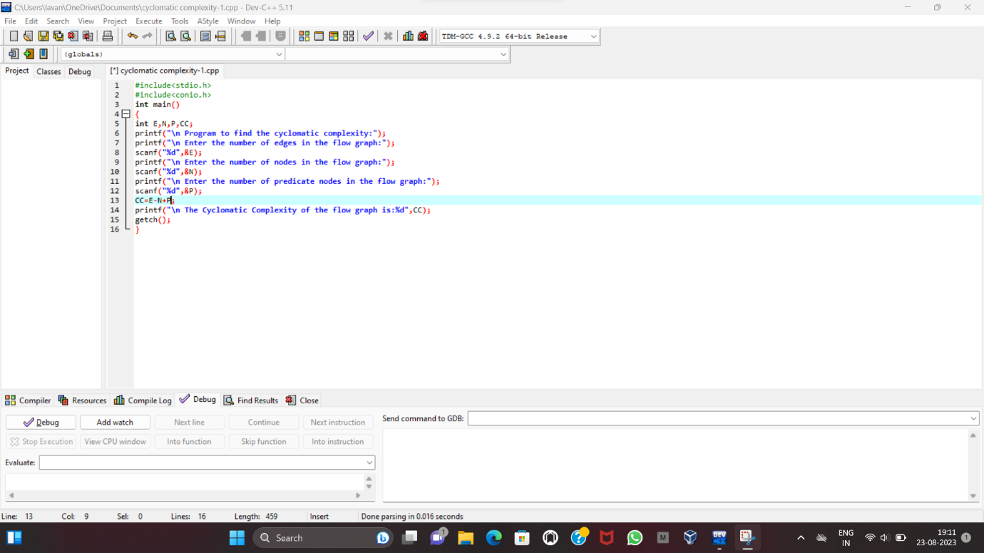

**OUTPUT:**

